ReactJS Hands-On Lab 4 - Output Report

Objective
Create a React application "blogapp" that fetches posts using componentDidMount and handles errors with componentDidCatch in a class-based component.

Environment Setup & Project Creation
Created a new React project using create-react-app and verified project creation:
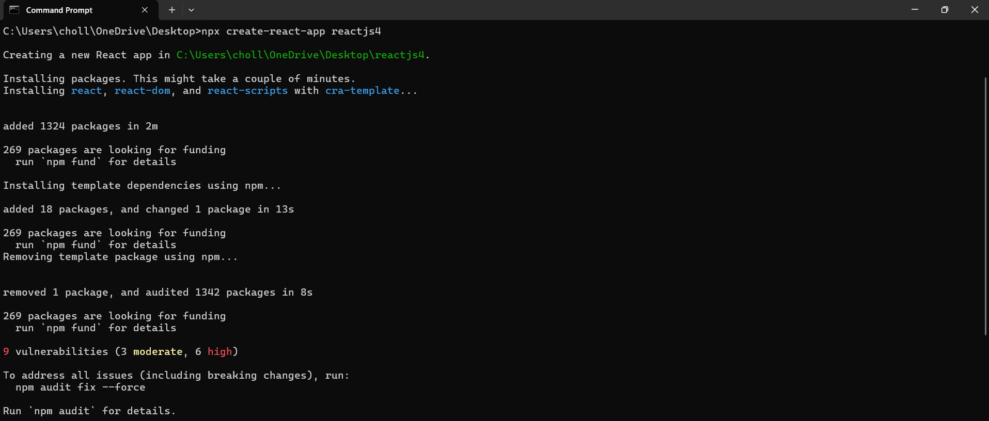

Project in VS Code
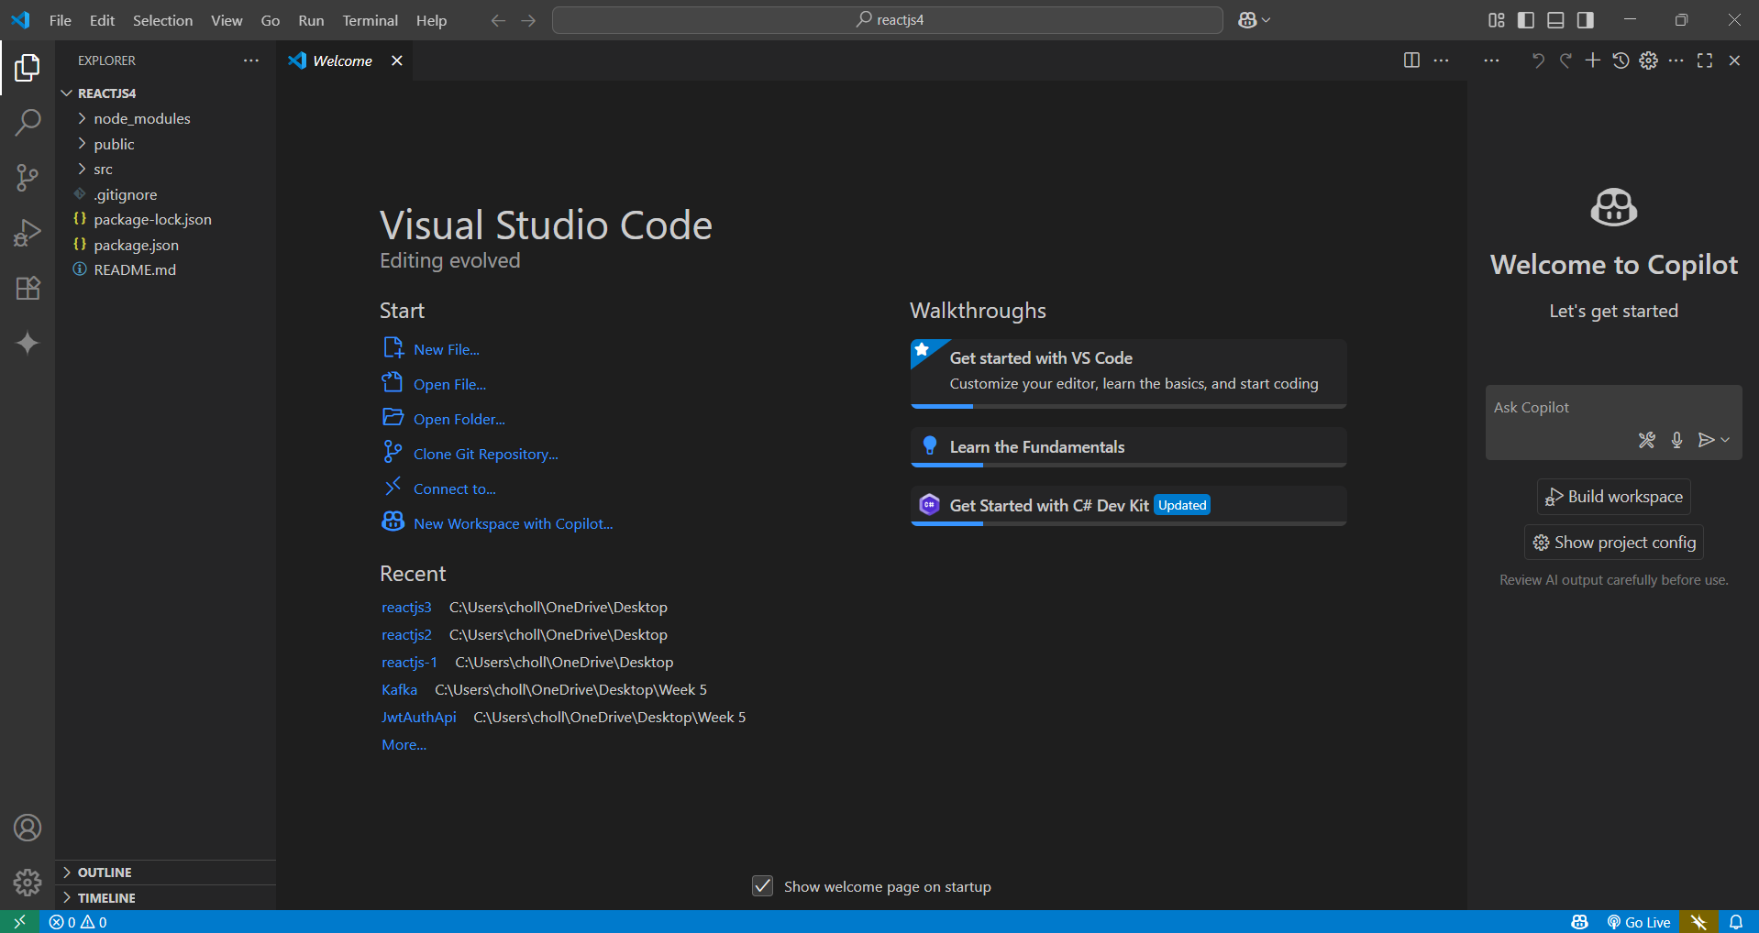

Posts Component
Created Posts.js class-based component implementing componentDidMount and componentDidCatch to fetch posts and handle errors:
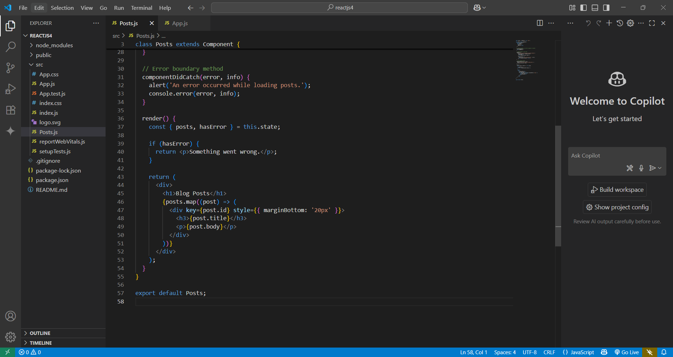

Edited App.js
Added Posts component to App.js to display fetched posts:
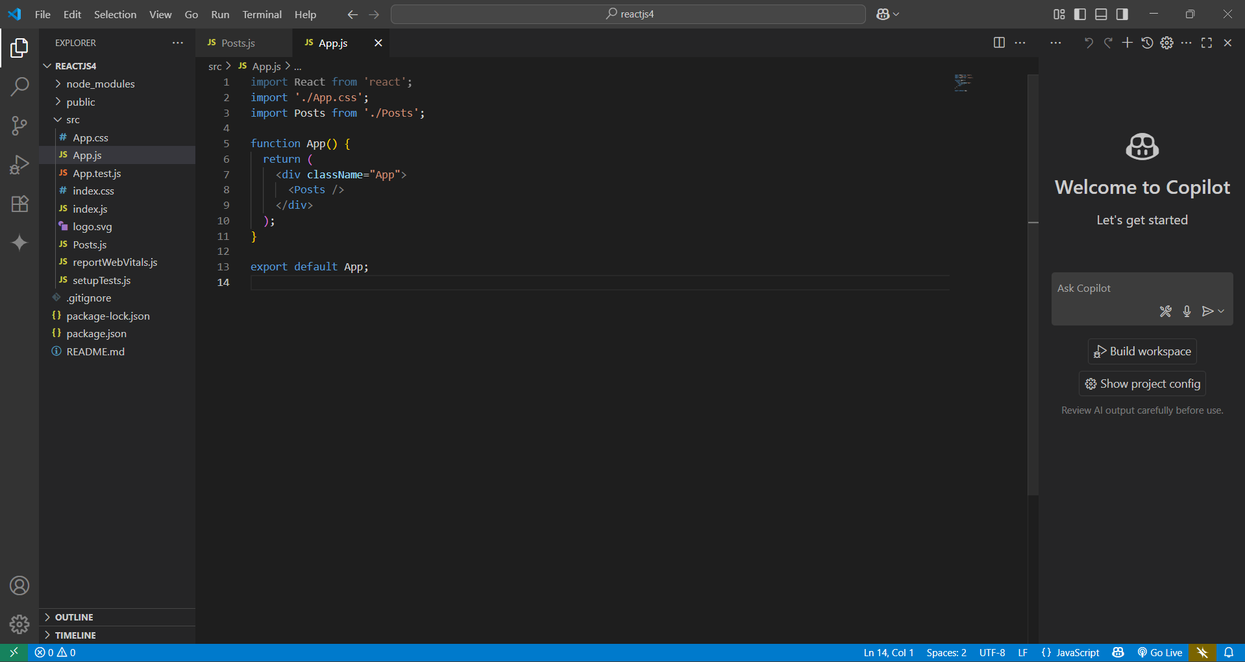

Webpack Compilation
Started the development server and verified successful compilation:
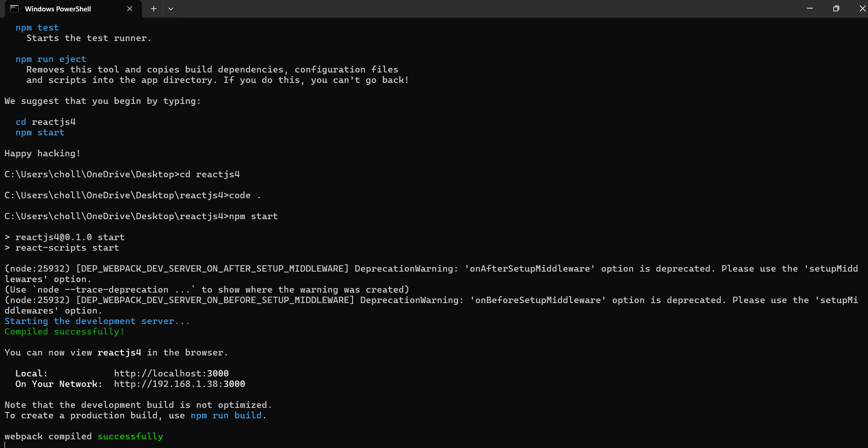

Browser Output
Verified that the React app displays posts fetched from JSONPlaceholder API in the browser:
